The goal of this project, Offerings Scraper, is to scrape information from the Course Offerings that you usually see under the CUD Student Portal.

Using the Browser Use AI Agent framework:

<https://browser-use.com/>

<https://github.com/browser-use/browser-use>

Your system should autonomously navigate as follows:

Your Offerings Scraper should login to the system as shown above.

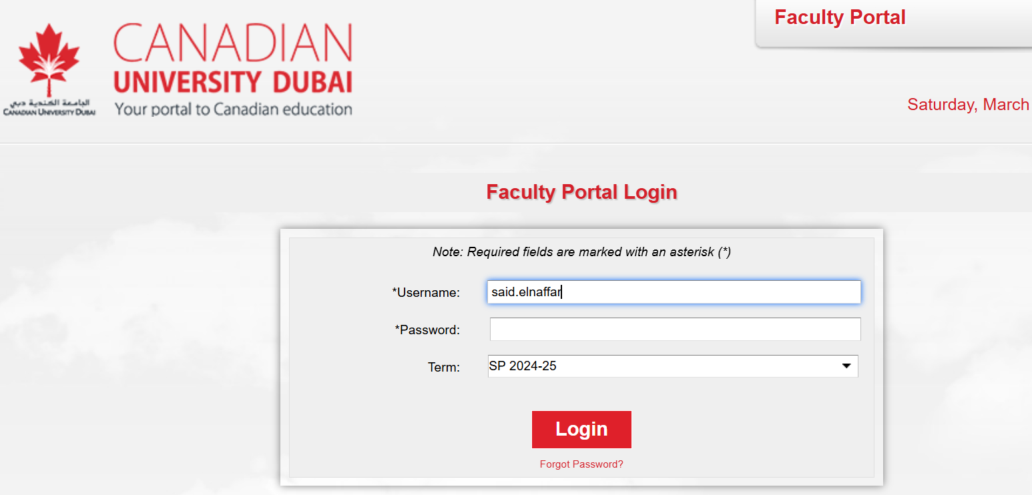

Let the AI Agent click on Offersing:

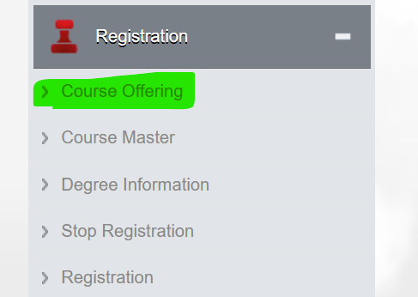

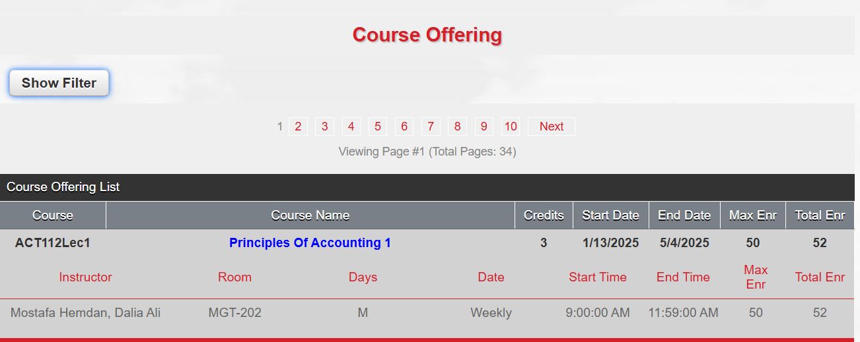

Click on “Show Filter”:

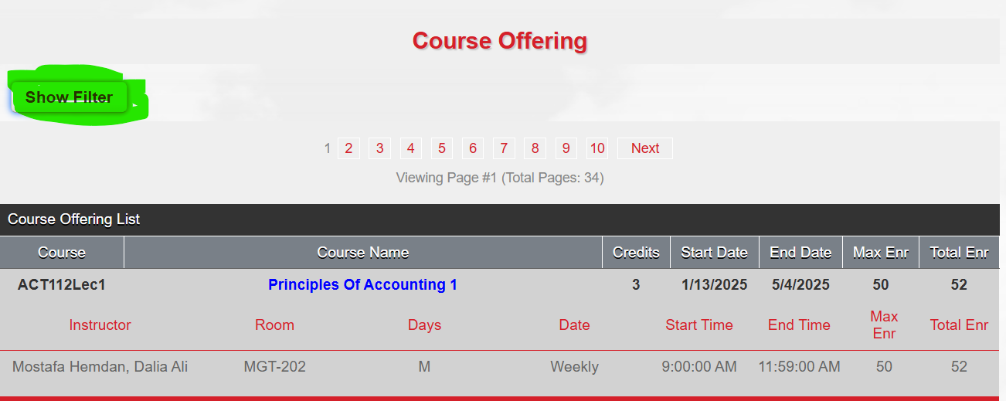

Let the AI Agent select “SEAST” from Divisions, and then click “Apply Filter”:

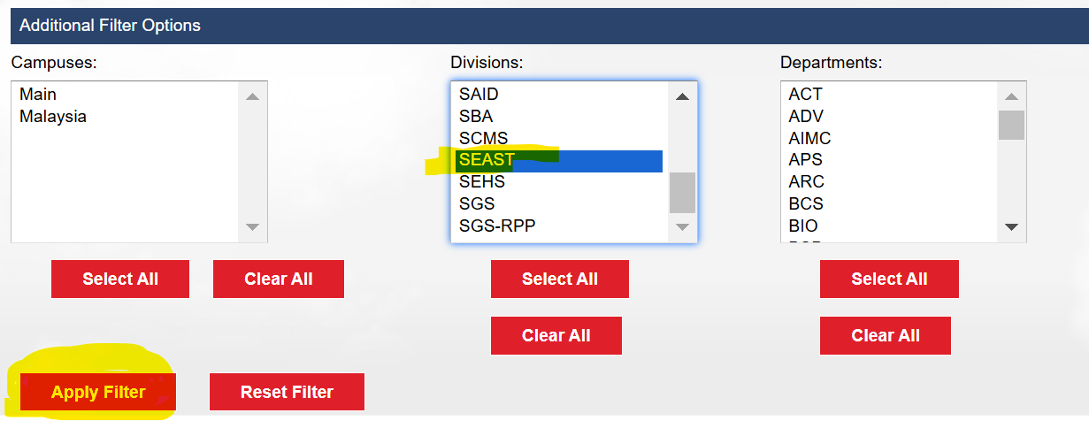

Extract the information related to EACH course as follows:

The Data Extracted and saved to a file in CSV format CSV:

Course,Course Name,Credits,Instructor,Room,Days,Start Time,End Time,Max Enrollment,Total Enrollment

ACT112Lec1,Principles Of Accounting 1,3,Mostafa Hemdan, Dalia Ali,MGT-202,M,9:00:00 AM,11:59:00 AM,50,52

ACT112Lec2,Principles Of Accounting 1,3,Abdul Aziz, Hesham,HUB-101,W,12:00:00 PM,2:59:00 PM,50,56

ACT112Lec3,Principles Of Accounting 1,3,Ouzan, Samuel,HUB-107,R,9:00:00 AM,11:59:00 AM,50,55

This file can be opened using Excel and data can be filtered as the user wishes.

